Vera Churchill Challenge: to spot 74 wildflowers in walking distance of Takeley? (They must be in flower.)
2012 – Yes, though it took careful planning – marsh, heath & woodland rides at the Forest, plus the Green Lane from the Church to the A120 overbridge.]
2013 – no [I was doing well till a cloudburst soaked my enthusiasm in Hatfield Forest]
2014 – part 1 (two hours and 1 mile)

Park just beyond the derestriction sign on Parsonage road, where radiocab drivers wait up for calls. Follow the old road, then round the field.
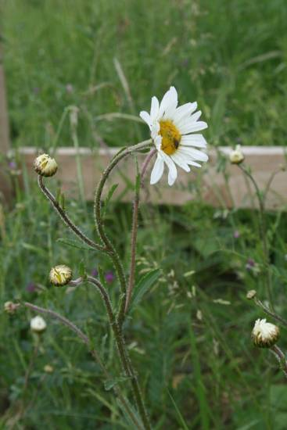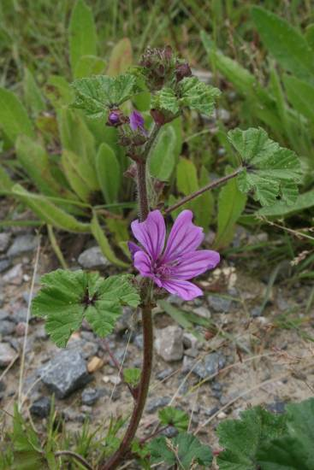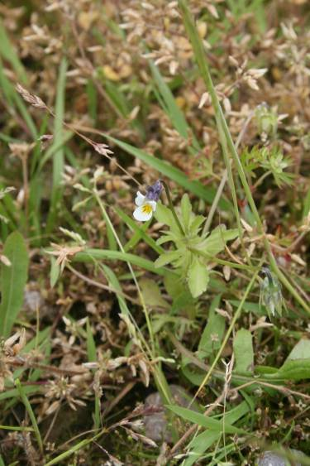
Oxeye Daisy Common Mallow Field Pansy
Chrysanthemum leucanthemum Malva sylvestris Viola arvensis

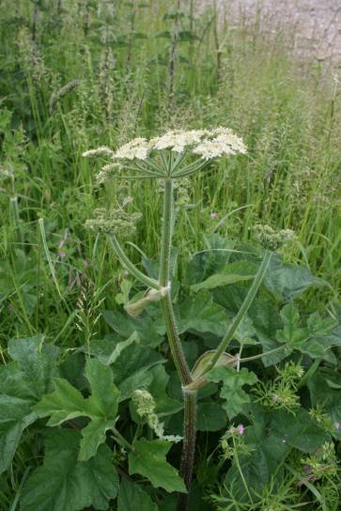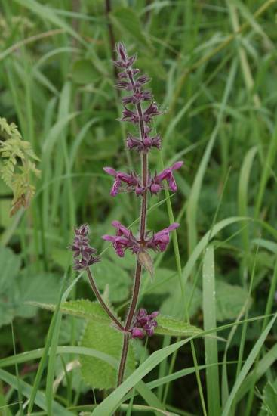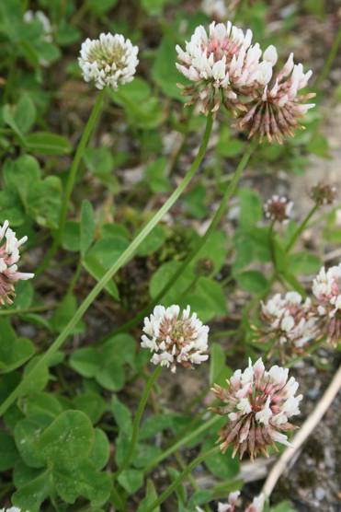
Hogweed Wood Woundwort White Clover
Heracleum sphondylium Stachys sylvatica Trifolium repens

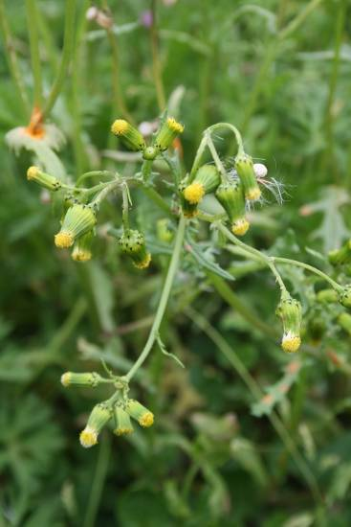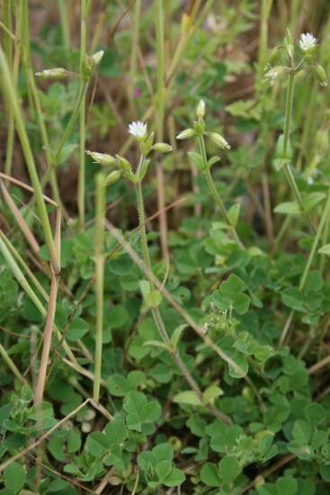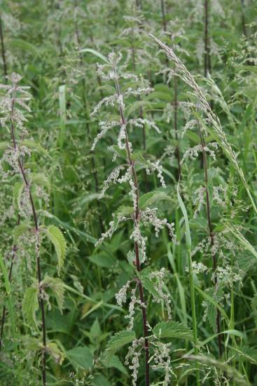
Groundsel Mouse-ear chickweed Nettle
Senecio Cerastium holosteoides Urtica dioica

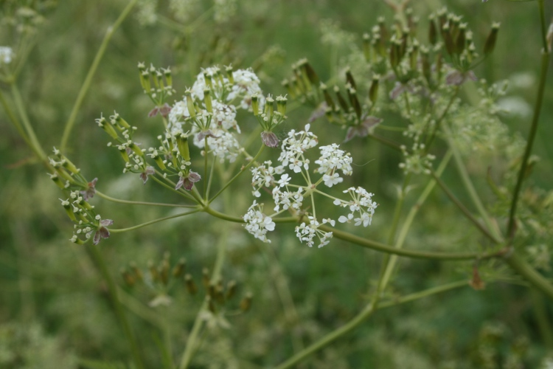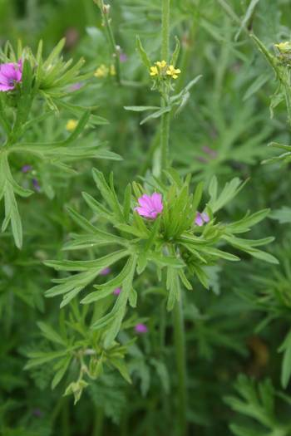
Cow Parsley Cutleaved Cranesbill
Anthriscus Geranium dissectum

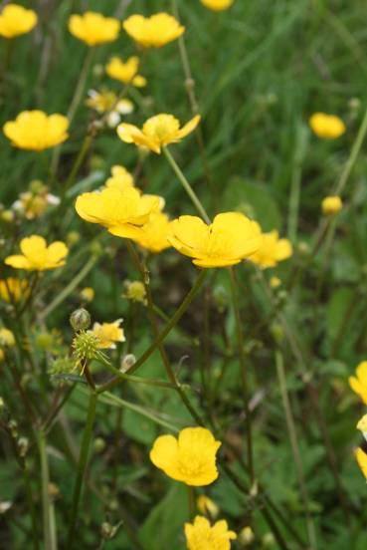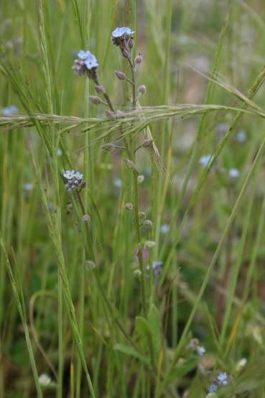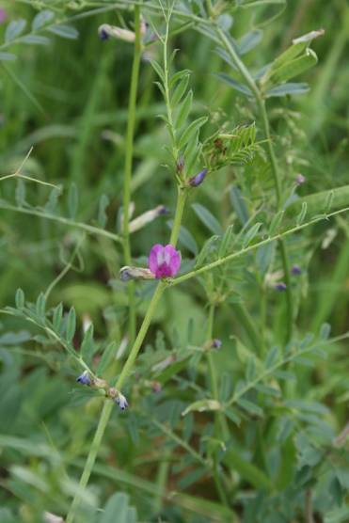
Buttercup Forget me not Common Vetch
Ranunculus acris Myosotis sp. Vicia sativa

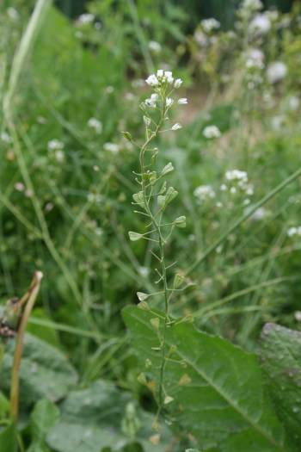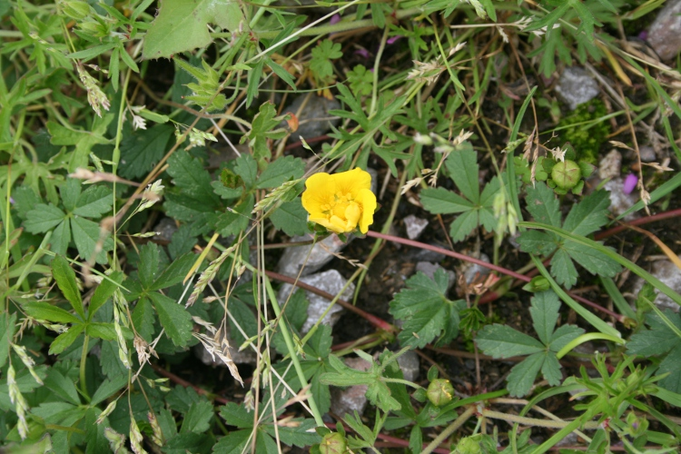
Shepherd’s Purse Cinquefoil
Capsella bursa-pastoris Potentilla reptans

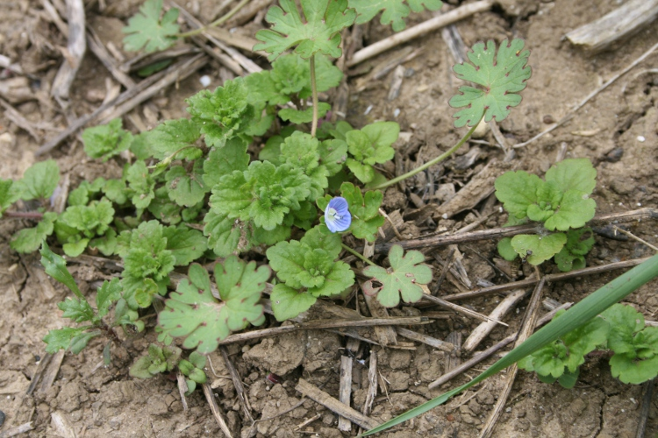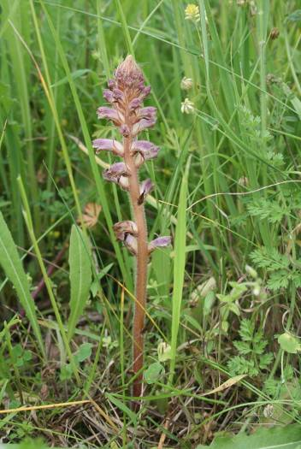
Persian Speedwell Lesser broomrape
Veronica persica Orobanche minor

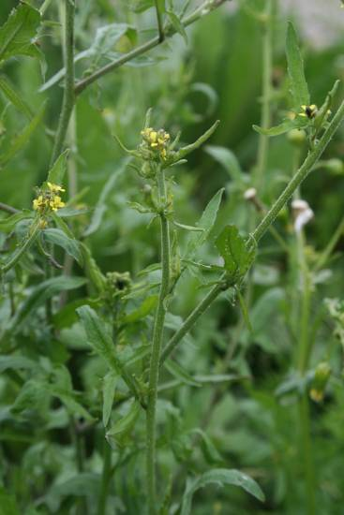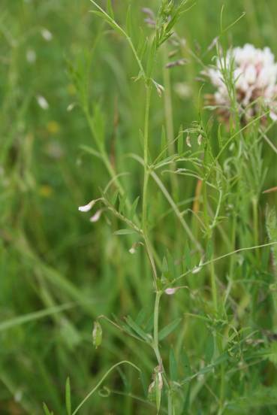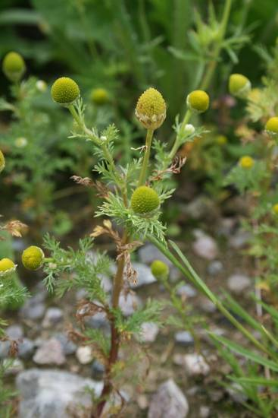
Charlock Hairy tare Scentless mayweed
Sinapis arvensis Vicia hirsuta [pink, blue, white] Matricaria matricarioides

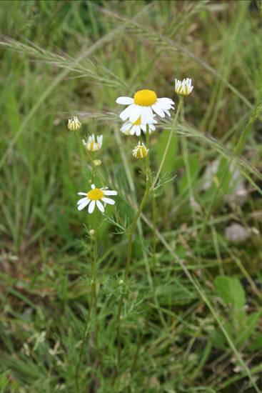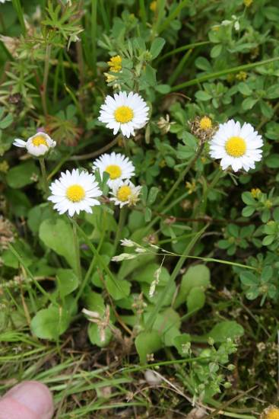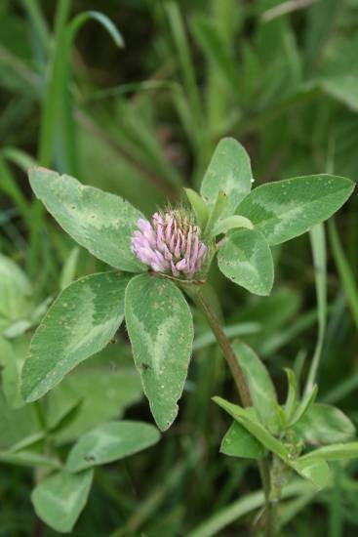
Corn chamomile Daisy Pink clover
Anthemis arvensis Bellis perennis Trifolium pratense

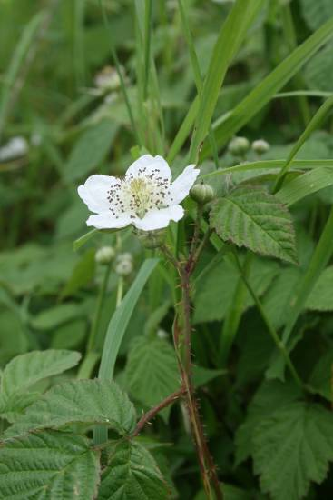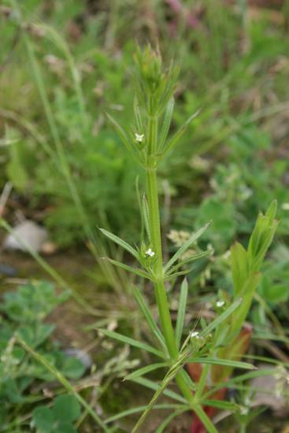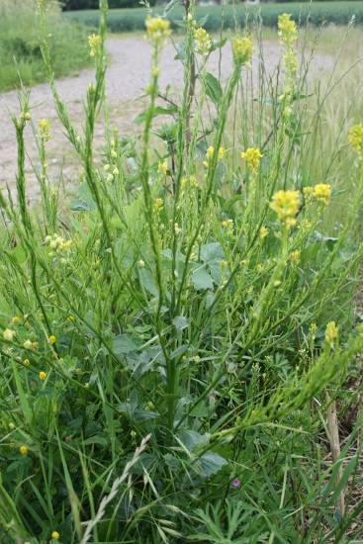
Dewberry Goosegrass Hedge Mustard
Rubus caesius Galium aparine Sisymbrium officinale
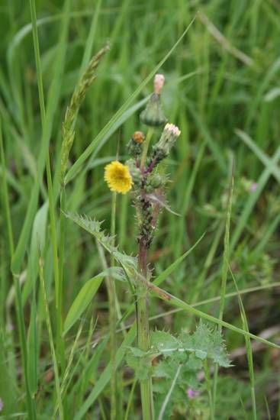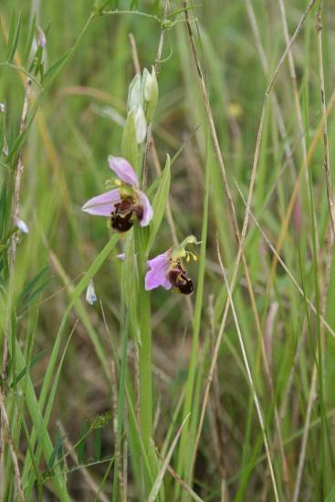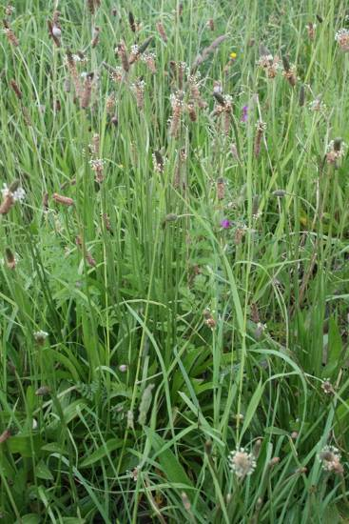
Prickly Sowthistle Bee orchid Plantain

Sonchus asper Orchis apifera Plantago major

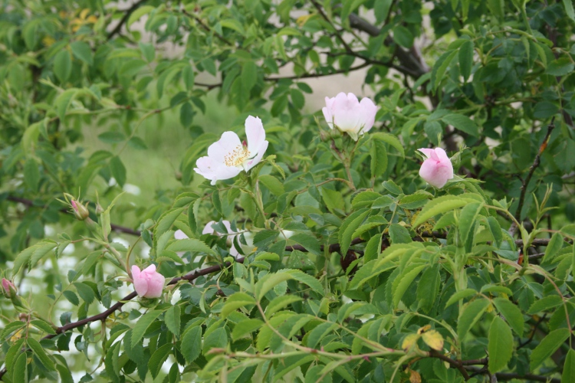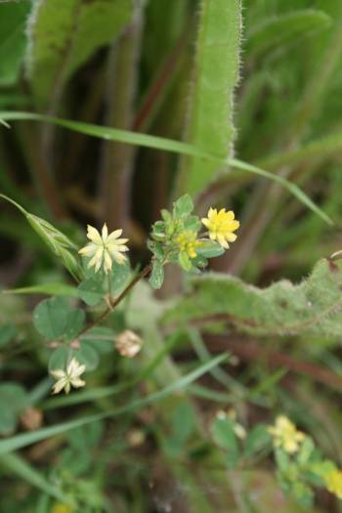
Briar Hop-trefoil
Rosa canina Trifolium campestre

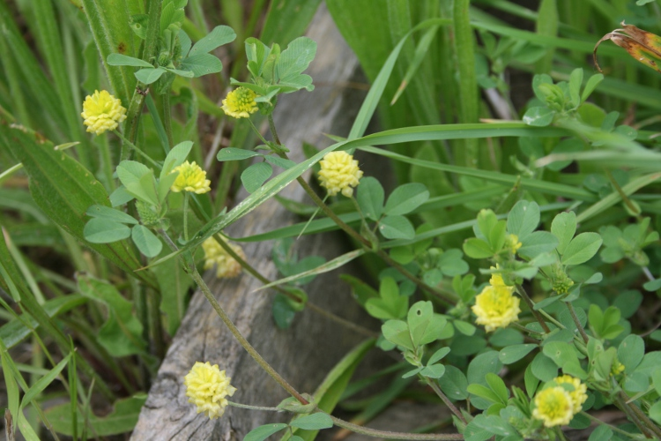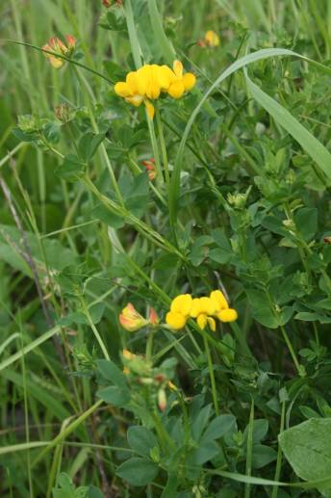
Large hop-trefoil Birdsfoot trefoil
Trifolium aureum Lotus corniculatus

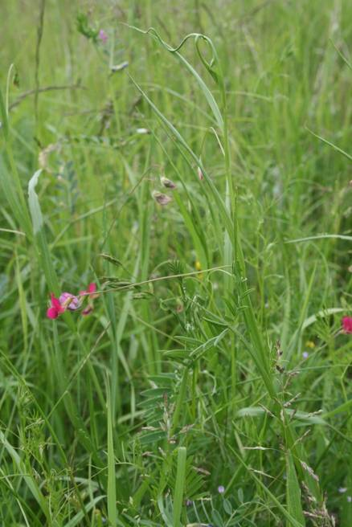 Grass vetchling Lathyrus nissolia
That’s 35 species and you’ve only gone 100 yards, gently downhill to the A120 fence.

Bee Orchids and broomrape are at their best [watch where you tread.] There is also Yellow-wort Blackstonia perfoliata [but it will be a couple of weeks to flowering] and Goatsbeard Tragopogon [but I was out in the afternoon so flowers were closed- “Jack-go-to-bed-at-noon!”]. They would take you half way to Vera’s score.
In a few weeks you can add salad burnet Poterium sanguisorba, common Centaury Centaurium erythraea and knapweed Centaurea.

Carrying on down the footpath round the field, near the ditch:
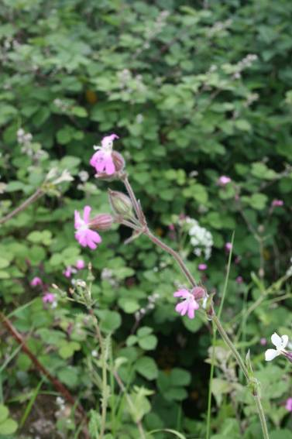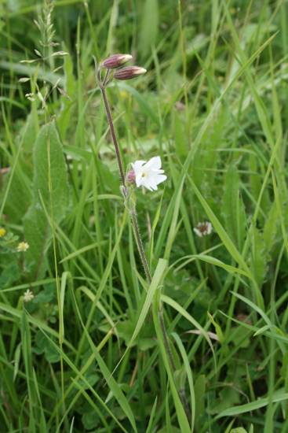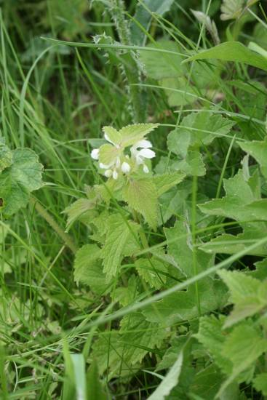
Red Campion & white Campion White deadnettle
Silene dioica and Silene alba, Lamium album.
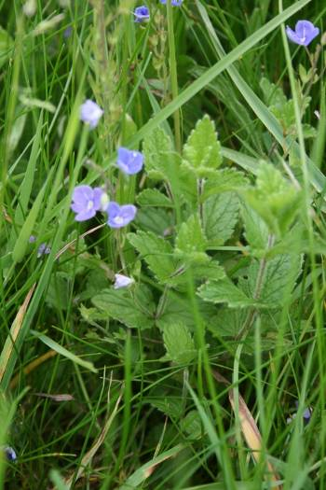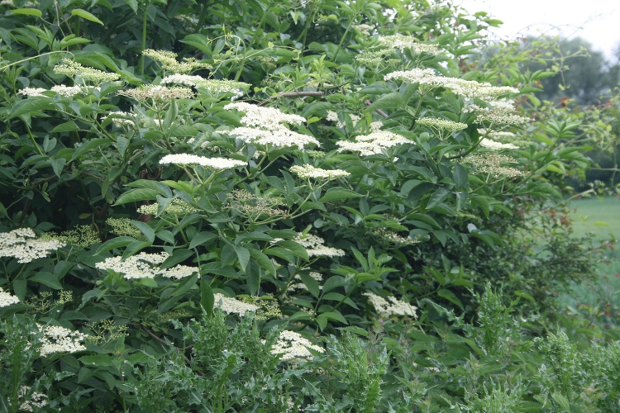
In the track, Germander Speedwell,Veronica chamaedrys In the hedge, Elder Sambucus nigra

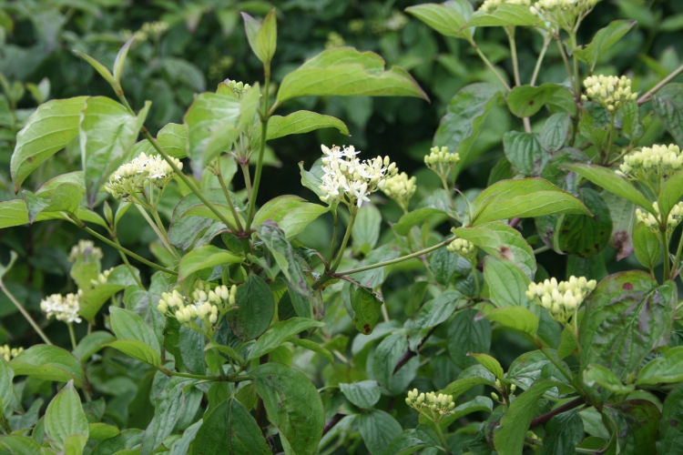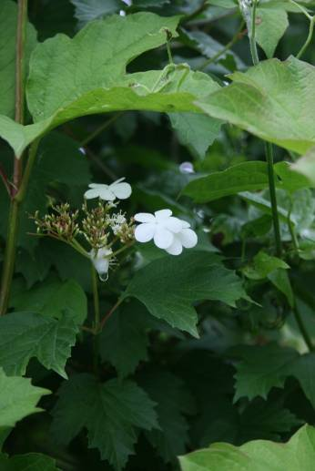
Dogwood Cornus sanguinea, and further along Guelder Rose Viburnum opulus

I also saw “nests” of Peacock and Small Tortoiseshell caterpillars in the nettles, a fat Burnet Moth caterpillar on Birdsfoot trefoil and a Drinker moth caterpillar sunning itself in the long grass. The grasses near the bridge are full of elongated silvery white Burnet moth cocoons. The red-and-black moths will be flying in three weeks or so.
While carrying on round the field margin the shaded areas are a bit behind everywhere else:
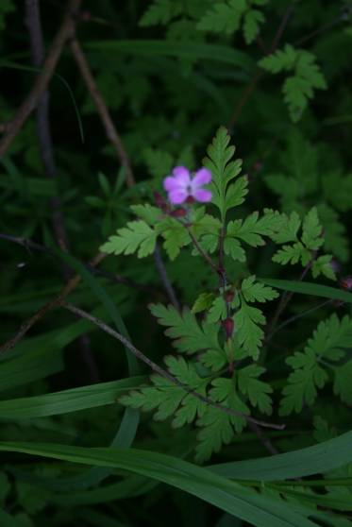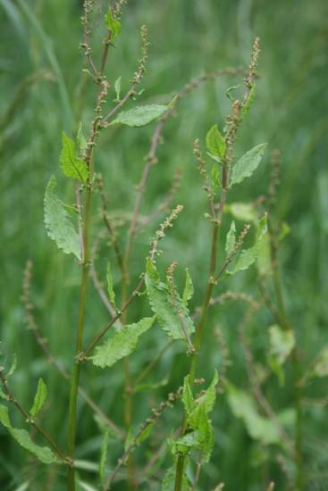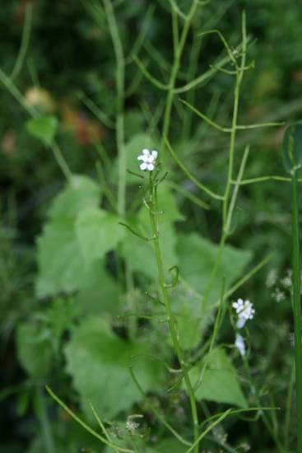
Herb Robert Dock Garlic Mustard
Geranium robertianum Rumex obtusifolius Alliaria petiolata

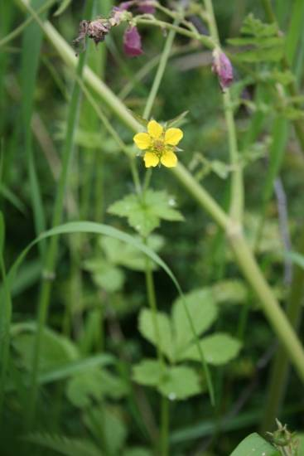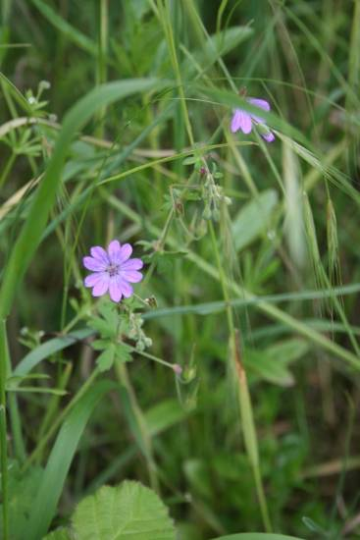
Wood avens Geum arvense And near the road Pyrenean Cranesbill Geranium pyrenaicum. That’s 47 species in flower in one field.
A short trip to the churchyard was disappointing. There were a dozen or so commoner plants from the list above. The ground ivy on the car park bank has been largely cut and I saw only leaves; the meadow grass has overgrown everything but Sorrel Rumex acetosa and, in one or two places, lucky survivals or re-growths of Bugle Ajuga reptans. There should also be bittercress Thlaspi and stonecrop Sedum in graves.
The May is long gone [in 2012 the pink hawthorn in the north-east corner lingered into June but not this year] and the gladdons Iris foetidissima in the shade are a week from opening. The limes Tilia europea will also be open in a week or so: worth a trip for the scent when they do.
The green way is overgrown with grass before the vetches and other plants have had a chance to show, so the diversion only added two to the score. Two hours gone and I am only two-thirds of the way to Vera’s score, so how much time did she spend collecting?

“Take nothing but photographs, leave nothing but footprints”

